November 22, 2022
Submitted via CFTC Portal

Mr. Christopher J. Kirkpatrick
Office of the Secretariat
Commodity Futures Trading Commission
Three Lafayette Centre
1155 21st Street, N.W.
Washington, D.C. 20581

Re: TW SEF LLC – Notice to Participants

Dear Mr. Kirkpatrick:
Pursuant to Section 5c(c) of the Commodity Exchange Act (the “Act”) and Section 40.6(a) of the regulations of the Commodity Futures Trading Commission (the “Commission”), Tradeweb SEF LLC (“TW SEF”) hereby notifies the Commission that it is self-certifying a Commodity Futures Trading Commission (CFTC) Swap Data Reporting (SDR) and public dissemination requirements Notice to All Participants of TW SEF LLC: SDR Reporting (the “Commodity Futures Trading Commission (CFTC) Swap Data Reporting (SDR) and public dissemination requirements Notice”). The Notice will become effective on December 7, 2022, no fewer than ten business days from the date hereof.

In connection with its submission, TW SEF hereby notifies the Commission that:

- TW SEF certifies that it has posted the Commodity Futures Trading Commission (CFTC) Swap Data Reporting (SDR) and public dissemination requirements Notice on TW SEF’s website and has provided this notification to the Commission;

- TW SEF certifies that the Commodity Futures Trading Commission (CFTC) Swap Data Reporting (SDR) and public dissemination requirements Notice complies with the TW SEF Rulebook, the Act and the Commission’s regulations; and

- No substantive opposing views with respect to the Commodity Futures Trading Commission (CFTC) Swap Data Reporting (SDR) and public dissemination requirements Notice were expressed to TW SEF by its governing board or committee members, members of TW SEF or market participants
Should you have questions regarding this submission, please contact the undersigned at (646) 767-4923 or by email at Devi.Shanmugham@tradeweb.com.
Very truly yours,
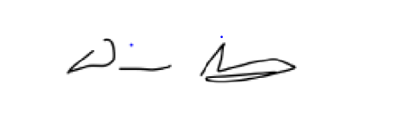
Devi Shanmugham
TW SEF CCO
Attachment A
Commodity Futures Trading Commission (CFTC) Swap Data Reporting (SDR) and public dissemination requirements Notice

