May 1, 2018

Assistant Secretary of the Commission for FOIA Matters
U.S. Commodity Futures Trading Commission
1155 21st Street, NW Room 2205
Washington, DC 20581

Re: FOIA Confidential Treatment Request
Dear Staff:
Pursuant to Section 145.9 of the U.S. Commodity Futures Trading Commission (the “Commission”) Regulations under the Commodity Exchange Act, as amended, DTCC Data Repository (U.S.) LLC (“DDR”) requests that the DTCC Global Privacy Policy being submitted to the Commission and the information contained therein (together, the “Documents”), be afforded confidential treatment until further notice under the Freedom of Information Act and the Commission's Regulations.

If you have any questions regarding this request, please contact the undersigned at 212-855-3038.

Very truly yours,

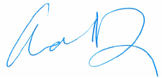

Adrienne Z. During
DDR Compliance Director

