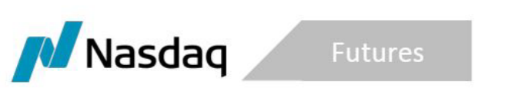
SR-NFX-2020-09 Exhibit A

March 26, 2020

NFX Natural Gas Clearing Fee Rebate Program
Introduction
NFX is offering a Rebate Program to encourage market participants to close their existing open interest (“OI”) in Natural Gas futures and futures options (“Natural Gas”). The Program will only apply to transactions conducted as part of a Matching Session to close Natural Gas OI on NFX and establish substantially similar positions on Nodal Exchange (“Matching Session”). The terms of the Rebate Program are as follows:
- NFX will rebate all OCC clearing fees incurred by market participants for transactions taking place during a Matching Session to close Natural Gas OI on NFX,
- The Rebate Program will be in effect from April 1, 2020 and April 30, 2020.
Customers will need to provide NFX with documentation of the clearing fees assessed by OCC for closing all Natural Gas positions in order to be eligible for the rebate.

